

Foundations of Programming

Assignment No.: 14
PROBLEM STATEMENT: Write a C program to input a binary number from the user and convert it into a decimal number.

OBJECTIVE:

- To understand number system conversions.
- To learn how to convert binary numbers to decimal numbers in C.
- To practice the use of loops and arithmetic operations.
- To develop logical thinking for number system problems.

THEORY:
A binary number system uses only two digits: 0 and 1. Each digit of a binary number represents a power of 2 depending on its position. To convert a binary number into its decimal equivalent, each digit is multiplied by 2 raised to the power of its position and the results are added together. In C programming, this conversion can be implemented using loops and arithmetic operations.

PLATFORM: Linux
ALGORITHM:
1 Start
2 Input a binary number (e.g., n).
3 Initialize decimal_number = 0, base = 1, and remainder.
4 While n > 0:
- Find the last digit of the binary number: remainder = n % 10.
- Multiply the digit by the current power of 2 and add to the result: decimal_number = decimal_number + (remainder * base).
- Remove the last digit from the binary number: n = n / 10.
- Update the power of 2 for the next position: base = base * 2.
5 Output the decimal_number.
6 Stop

INPUT: Binary number entered by the user
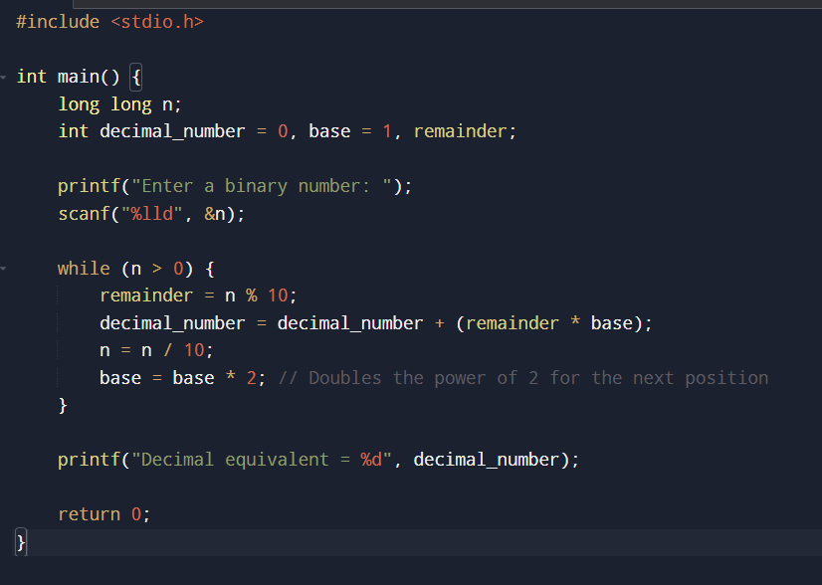

OUTPUT: Displays the decimal equivalent of the given binary number.
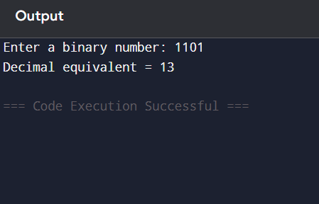
CONCLUSION: Thus, the C program successfully converts a binary number entered by the user into its decimal equivalent using loops and arithmetic operations.

FAQs:
- What is a binary number system?
- How is a binary number converted into a decimal number?
- What is the role of loops in binary to decimal conversion?
- What is the role of the pow() function in this program?
- What is the data type used to store binary and decimal numbers in this program?

